

Registration form

CHILD’S DETAILS
Forename: …………………………………….. Surname: …………………………………
Gender: ………………………………………. DOB: ……………………………….
Address: …………………………………………………………………………................................................
………………………………………………………………………………………………....................................
Postcode: ..............................................
Passport Reference:…………………………. Birth Certificate Reference: ………………………
PARENT/CARER’S 1 DETAILS
Name: …………………………………………………..............................DOB: ……………………………….
National Insurance Number: ........................................................
Address: ....................................................................................................................................................
……………………………………………………………………………………………………............................
Telephone: …………………………………….. Mobile: ...............................
Email Address: ………………………………………………………..
Does this child live with you? Yes / No (Circle)
Does this parent have parental responsibility? Yes or No (Circle)
PARENT/CARER’S 2 DETAILS
Name: ………………………………………………….............................DOB: ……………………………….
National Insurance Number: ........................................................
Address: ....................................................................................................................................................
……………………………………………………………………………………………………............................Does this child live with you? Yes / No (Circle)
Does this parent have parental responsibility? Yes or No (Circle)
Telephone: …………………………………… Mobile: ………………………………........
Email Address: …………………………………………………………………….

Emergency contact details
Parent 1 – work/daytime contact number …………………………………………………
Parent 2 - work/daytime contact number …………………………………………………
Any other emergency contact numbers
Name: …………………………………………………
Telephone: ………………………………… Mobile: ………………………………………….
Name: …………………………………………………
Telephone: ………………………………… Mobile: ………………………………………….

Personal authorised to collect the child (must be over 16 years old)

Name: …………………………………………………………
Relation to child: …………………………………………………..
Telephone: ………………………………… Mobile: ………………………………………….
Name: …………………………………………………………
Relation to child: …………………………………………………..
Telephone: ………………………………… Mobile: ………………………………………….
Personal details of the child
Does your child have any special dietary needs or requirements?
Yes/No (Circle)
More Detail: ……………………………………………………………………………………………...............
……………………………………………………………………………………………………………...............
Is your child allergic to anything?
Yes / No (Circle)
More Detail: ……………………………………………………………………………………………...............
……………………………………………………………………………………………………………...............
Is your child on any medication? Yes / No (Circle)
If yes, give details: …………………………………………………………………………………………………………..

Please list immunisations: ………………………………………………………………………………….....
………………………………………………………………………………………………………………..............
Seen Red Book? Yes/No (Circle) (Setting)
Has your child had their 2-year check? Yes/No (Circle)
If yes, what where their results?
…………………………………………………………………………………………………………………
…………………………………………………………………………………………………………………
What is the main religion in your family? …………………………………………
Are there any festivals or special occasions celebrated in your culture that your child will be taking part in and that you would like to see acknowledge and celebrate while he/she is in our setting? ………………………………………………………………………………………………………………
What language(s) is/ are spoken at home: ………………………………………
If English is not the main language spoken at home, will this be your child’s first experience of being in an English-speaking environment? Yes/ No (Circle)
If so, discuss and agree with the key person how you will support the child when setting in.
………………………………………………………………………………………………………………
………………………………………………………………………………………………………………
Does your child have any special needs or disability? Yes/No (Circle)
Details: …………………………………………………………………………………………
What special support will he/she require in our setting?
………………………………………….…………………………………………………………………
…………………………………………………………………………………………………………….
What other information is it important for us to know about your child? For example, what they like, or what fears they may have, any special words they use or what comforter they may need and when.
What they like? .................................... What are their fears? .....................................................
Have they got a comforter? Yes/No (Circle) If yes, give details ……………………………………….
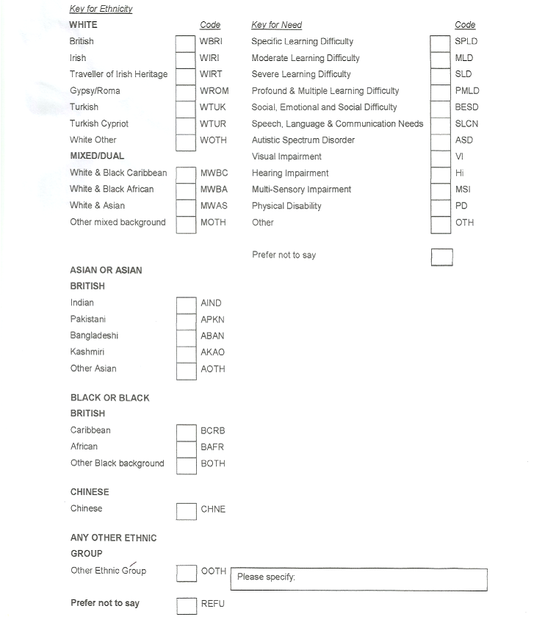

NAME OF PROFESSIONAL(s) INVOLVED WITH MY CHILD
Family Doctor: …………………………………………
Address: ……………………………………………………………………….
Telephone: ………………………………………

Family Dentist: …………………………………………
Address: ……………………………………………………………………….
Telephone: ………………………………………

Health Visitor: ……………………………………
Address: …………………………………………………………………………
Telephone: ………………………………………

Does your family have a social worker for any reason?
Yes/No (Circle)
Name: ………………………………………… based at: ………………………………………
Telephone: ……………………………………………
What is the reason for the involvement of social services with your family?
…………………………………………………………………………………………………………….
…………………………………………………………………………………………………………….
NB if the child is on the child protection register, make a note here, but do not include details. Ensure these are obtained from social worker named above and keep these securely in the child’s file.
Have you or any immediate family relation been involved in Domestic Abuse? Yes/No (Circle)
Was this question asked in person on induction? Yes/No (Circle) (Setting)
SESSIONS REQUIRED (Please specify times)
 | Am | Pm
Monday
Tuesday
Wednesday
Thursday
Friday
To be completed by the key person/Manager

Date starting: …………………………………………………

Days and times of attendance: ………………………………………………

Are any fees payable? If so, note here ……………………………………………..

Name of key person: ……………………………………………………………

Name of back up key person: …………………………………………….

Has the settling – in process been agreed? Yes/No (delete)

If so, detail …………………………………………………………………………………………..
……………………………………………………………………………………………………………..
Signed by
Parent 1: ……………………………………

Key person: ………………………………………

Date: …………………………………………………………..

Parent 2: ……………………………………

Key person: ………………………………………

Date: …………………………………………………………..
Where did you hear about us?
- Advertisements, i.e. poster, leaflets

Please specify: ......................................................
- Friend
Please specify: ......................................................
- Family
- Yellow pages
- National day nursery
- Thompson’s directory
- Other
Please specify: ......................................................

Full Day Care Terms and Conditions
- A registration fee of £50 is needed 1 week before your child’s start date or on the day your child starts. This will be non-refundable.
- Fees must be paid in advance or on the first day of care.
- Cheques are to be made out to Pebbles Pre - School. An administration charge of £25.00 will be charged for cheques that are not honoured due to lack of funds.
- Fees MUST be paid even if your child is absent because of illness or holidays.
- A fee of £2 will be charged if children are not collected on time and an additional £2 per child for every five minutes after their collection time, unless under exceptional circumstances and at the managers discretion.
- Four weeks written notice is required if a child is leaving and fees are still payable during this period.
- We will give 1-month notices of any increase of fees.
- Account cannot be allowed to run into arrears. Please discuss any payment difficulties with us as soon as possible.
- We need to know in advance who will be picking up your child. We will not let your child go with anyone else. Please telephone prior to collection of your child the name and password which shall be used to confirm the identity of the person collecting your child.
- Please inform us of any change of contact numbers.
- If a child seems unwell, we will call you to arrange for someone to collect him/her.
- We must have an emergency phone number of someone who can pick up your child if you are held up or unable to get here.
- Please ring us on 07854030710 or 01582 524034 as soon as you know your child will be absent or a member of Pebbles Pre-school will contact you within an hour of your child’s start time.
- Please inform us of any changes regarding your child’s medical details.
- If you wish to change sessions, please give us a months’ notice, if possible. Changes will be made if places are available.
- Does your child have a nap (yes or no)
- In school holidays children who are not attending are still required to pay half fees, this is due to the management keeping your child’s space secure until your child returns

This document is a legally binding document between parents of the children attending and Pebbles Pre-school.
I have read this document and understand it fully and agree to abide by these terms and conditions as written down this document.

Parent’s Signature ………………………… Date …………………………….

Staff signature: ....................................... Date: .....................................

Sessional care Terms and conditions
- A registration fee of £50 is needed 1 week before you child’s start date or on the day your child starts. This will be non-refundable.
- Fees and deposits must be paid in advance or on the day of care.
- Cheques are to be made out to Pebbles Pre - School. An administration charge of £ 25.00 will be charged for cheques that are not honoured due to lack of funds.
- Fees MUST be paid even if your child is absent because of illness or holiday.
- A fee of £2 will be charged if children are not collected on time and a additional £2 per child for every five minutes after their collection time, unless under exceptional circumstances and at the managers discretion.
- Four weeks written notice is required if a child is leaving and fees are still payable during.
- We will give a months’ notice if we need to increase charges
- Accounts cannot be allowed to run into arrears. Please discuss any payment difficulties with us a soon as possible.
- We need to know in advance who will be picking up your child. We will not let your child go with anyone else. Please telephone prior to collection of your child the name and password which shall be used to confirm the identity of the person collecting your child.
- Please inform us of any changes in address and telephone numbers.
- If a child seems unwell, we will call you to arrange for someone to collect him/her.
- We must have emergency phone number of someone who can pick up your child if you are held up or unable to get here.
- Please ring us on 07854030710 or 01582 524034 as soon as you know your child will be absent or a member of Pebbles Pre-school will contact you within an hour of your child’s start time.
- Please inform us of any changes regarding your Childs medical details.
- If you wish to change sessions, please give a months’ notice, if possible. Changes will be made if places are available.
- In school holidays children who are not attending are still required to pay half fees, this is due to the management keeping your child’s space secure until your child returns.

This document is a legally binding document between parents of the children attending and Pebbles Pre-school.
I have read this document and understand it fully and agree to abide by these terms and conditions as written down this document.

Parent’s signature: ………………………………… Date: …………………………….........

Staff signature: .............................................. Date: ..............................................

Permission slip
From time to time we like to take the children to our local library for a story time session, nature walks and picnics. We therefore ask for your permission to take your child (ren) off site to attend these sessions. Could you please sign below to confirm whether you agree or disagree to any of the items listed below. Thank you.
I am happy that Pebbles Pre-School store my child’s information in the child’s details folder.
Parent's/ Guardians signature: …………………………………………...
I am happy / I am not happy for my child (ren) to be taken off site.
Parent's/ Guardians signature: …………………………………………...
I am happy / I am not happy, for any qualified member of Pebbles staff to administer first aid to my child (ren) or to seek emergency medical advice or treatment.
Parent's / Guardians signature: ……………………………………………
I am happy / I am not happy, for any Pebbles staff taking any photographs of my child (ren) for journal purposes.
Parent's / Guardians signature: ……………………………………………
I am happy / I am not happy for my child (ren) photo’s to be put in other children’s leaving journal.
Parent's / Guardians signature: ……………………………………………
I am happy / I am not happy, for my child’s photographs/work to be used for advertising purposes, and/or shared on our social media (Facebook, Instagram, twitter page)
Parent's / Guardians signature: ……………………………………………
I am happy / I am not happy, for any member of Pebbles staff to change nappies or any other items of clothing as and when necessary or to take them to the toilet when needed.
Parent's / Guardians signature: ……………………………………………
I am happy / I am not happy, for any member of staff to administer sun cream to my child (ren) as and when necessary.
Parent's / Guardians signature: ……………………………………………
I am happy / I am not happy for information to shared with outside agencies i.e. transition with schools, ISCAN team, Children & Family Services, Speech & Language.
Parent's / Guardians signature: ……………………………………………

Entry Record
Name: ..................................... D.O.B: ................................ D.O.E: ................................
PREVIOUS PRE – SCHOOL EXPERIENCE

PERSONAL, SOCIAL AND EMOTIONAL DEVELOPMENT
Is able to feed self using spoon/fork/ knife
Is able to drink from an open cup
Is able to wash own hands/face.
Is toilet trained
Dresses and undresses self (puts on shoes)
Removes/ puts on simple items of clothing (puts on coat)
They like:
Comments:

COMMUNICATION, LANGUAGE/ LITERACY
Communicates clearly using speech, ‘sign language’, symbols or communication aids
Uses sentences of four or more words
Enjoys looking at books
Starts at the front and turns the pages of a book one at a time
Enjoys hearing stories read
Joins in with songs and rhymes (what’s their favourite song?)
Responds to own name when called
Can write own name
Comments:

MATHEMATICS
Can recite numbers to:
Can count objects to:
Recognises number symbols:
Knows how old he/she is
Shows interest in numbers in the environment. (e.g. house number, bus number)
Comments:

PHYSICAL DEVELOPMENT
Can use scissors
Can walk unaided
Can run unaided
Can climb unaided
Can ride three wheeled trikes
Can ride two wheeled bicycles
Can kick a ball
Can throw/catch a ball
Explores writing, by making marks on paper
Can write own name
Can thread beads and buttons
Has established hand preference: Left/ Right
Comments:

UNDERSTANDING OF THE WORLD
Can talk about concepts: hot/cold
Clean/dirty
Wet/dry
Hard/soft
Can talk about weather: sunny
Rainy
Windy
Can identify main body parts
Can use variety of tools
Is able to build a tower
Takes part in messy activities
Asks questions about what, why and where
Comments:

EXPRESSIVE ART AND DESIGN
Responds to music, songs and rhymes
Enjoys exploring sound using musical instruments
Participates in imaginative play
Enjoys Imaginative play with dolls/soft toys
Enjoys playing with miniature toys
Enjoys exploring messy activities
Comments:

